Name: ___________________________
Teacher: _________________________
Grade: ___________________________

2024 Eager Reader Bookmark Design

To get ready for Eager Reader – our annual reading incentive program – starting in in January 2024, our Eager Reader Bookmark Design is back for the
2nd year! Students loved the bookmark choices last year so we will copy many of the student-designed bookmark submissions and have them available for Discovery students to take home when their class comes for their Eager Reader book selection in January and February 2024!

All Discovery students are encouraged to design a bookmark! Please follow the steps below:
- Do not cut out the above bookmark. Turn in this whole form intact. If you need an additional form, you can print a copy from discoveryptsa.org.
- Only ONE submission per student; designs need to be ORIGINAL ARTWORK (no copyrighted material) and MUST be designed and created by the student. Art and design can be of any theme.
- Bookmark designs can be in color or black and white; keep in mind that designs will need clear handwriting (not too small!) if desired, and designs should not be overly intricate as they may not reproduce properly.
- Digital art designs are acceptable as long as they are created by the student. If you create your own, ensure that your bookmark fits in the form above.
- The student’s full name and grade need to be included with the bookmark design but NOT written on bookmark design area.
- Designs will need to be submitted in physical form (no email submissions allowed) and be able to be copied and/or scanned so no 3D textures, glue, or glitter.

Entry Deadline: Wednesday, December 13, 2023
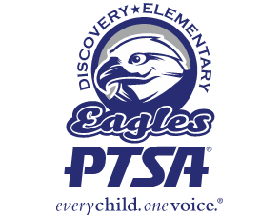
Drop off in the labeled basket in the Discovery Library!

